Using this guide
This guide accompanies the National Treasury’s Strategic Procurement Framework (SPF) for Strategic Sourcing in the Public Sector. For more information, visit the National Treasury website at http://ocpo.treasury.gov.za/

- DETERMINE APPROACH TO THE MARKET
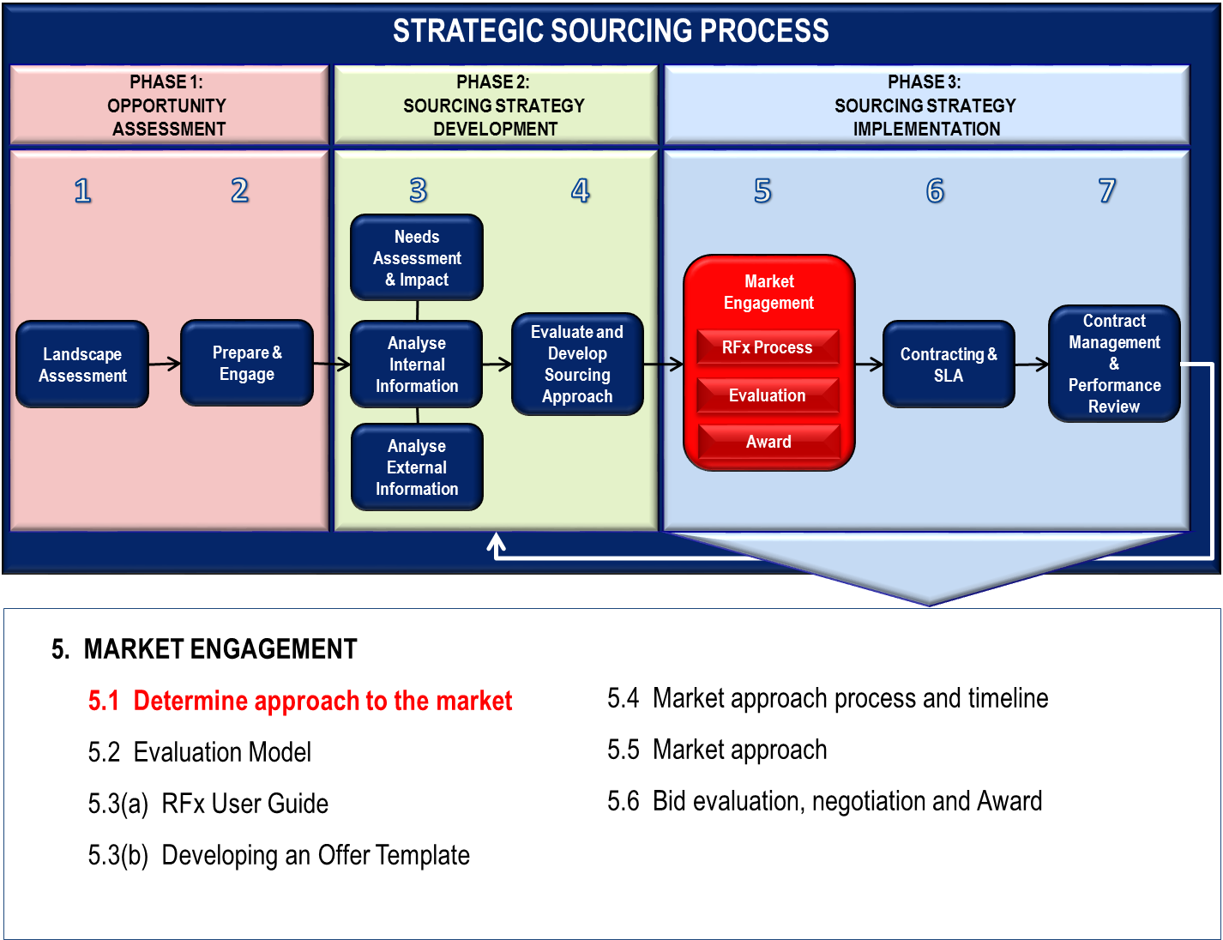
The process of determining the approach to the market is the result of all the analysis and thinking to date. This stage is the start of Phase 3 – Sourcing Strategy Implementation, which was developed during the previous stages. Market approach is how you choose to interact with the market. It requires a structured approach that satisfies fairness, equity, competitiveness, cost effectiveness and transparency.
- STRATEGY TO APPROACH THE MARKET
This stage involves deciding an appropriate approach to market, evaluation methodology, process plan and realistic timetable. It brings together your analysis and thinking to date. It results in a sourcing plan.
There are several process options that may be considered. These include:
- Pre-tender supplier engagement, such as EOI (Expression of Interest), RFI (Request for Information)
- Pre-qualification of suppliers through a RFP (Request for Proposals) in which suppliers will be evaluated on capability and functionality?
- Open or closed tender?
- Single stage or multi-stage tender?
- One or two envelope system?
- Type of RFx document required (RFI, RFQ, RFP, RFB)?
- Departure from current procurement policy, with compelling justification?
- Advertising the opportunity (E-tender portal, industry publications, media)?
- Will alternative proposals be considered?
- MATCHING MARKET APPROACH TO CONTEXT
In moving away from a ‘one size fits all’ approach to procurement, there is a need to review the options to establish:
- Which procurement method promises the most value-effective procurement process for the prevailing market conditions?
- Do different procurement methods comply with policy?
- How can any non-compliance issues be resolved?
- Which procurement method best suits which procurement contract?
- What is the basis for selection?
- Who makes the decision?
The ability to select the appropriate procurement method is one of the professional skills required to drive increased value from procurement.
  - What does the Positioning Matrix propose?
Your business case brings together your analysis and thinking to date. It would have resulted in the placement of your commodity in one of the four quadrants on the Sourcing Category Positioning Matrix. This will give you an indication of the market approach you want to follow.
Refer to SPF GOOD PRACTICE GUIDE- COMMODITY POSITIONING for more detailed explanation of the characteristics, strategy, tactics, actions and approaches that can be considered for each quadrant of the Positioning Matrix.
The table below indicates the possible paths to market based on the complexity of the procurement.
Potential path-to-market options for each complexity quadrants
LEVERAGE  - Transversal Contracts  - Panels of service providers  - Early supplier engagements  - Open competitive bidding  - Reverse Auctions | STRATEGIC  - Transversal Contracts  - Alliance arrangements  - PPP’s  - Inter-government delivery arrangements  - Procurement specific designed arrangements  - Multi-stage engagements
ROUTINE / TRANSACTIONAL  - E-systems  - Buyer-site  - Quotes  - Open competitive bidding | BOTTLENECK  - Early supplier involvement  - Multi-stage invitation process  - Reverse Auctions  - E-systems  - Direct negotiation  - Inter-government delivery arrangements

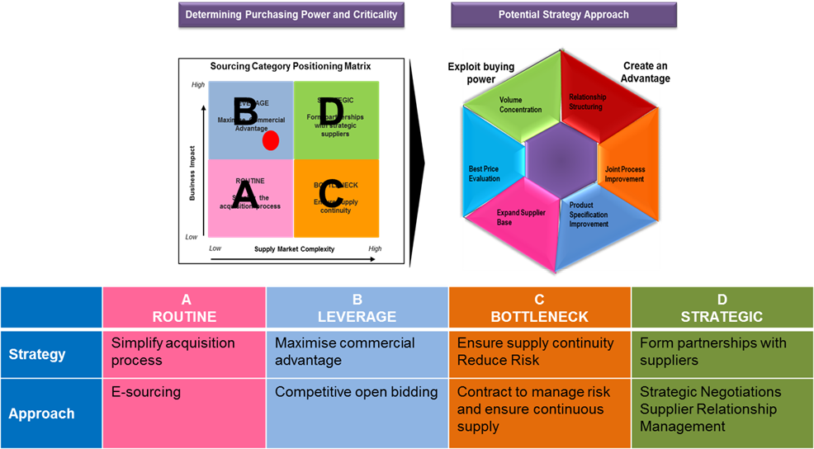
  - Possible considerations in selecting the optimal path to market
The list below states the different considerations when choosing the optimal path to market. Where an assessment indicates a range of market engagement options, your approach should apply the most cost-effective option for buyer and supplier with a focus on encouraging participation by local businesses and SMMEs.
To what extent do the following impact on selecting the optimal path to market?
- Is complexity assessed as routine or leveraged?
- Is complexity assessed as bottleneck or strategic?
- Does the activity require a high degree of customisation?
- What is the risk level associated with the activity?
- Does a competitive market exist and are alternate goods and services available?
- Does the market feature new players/new technologies?
- Can the activity be satisfied by different solutions?
- Is the activity associated with very specific non standard requirements?
- Does the activity support a high level of innovation or non standard delivery arrangement?
- Is the capability of the organisation assessed as being able to manage the risk level associated with the activity?
- Will the materiality of activity (size, value, scope) have a significant impact on the market?
- Is the cost to the department in conducting market approach a significant factor in the path to the market selection?
- Is cost to suppliers a key factor in the path to market selection?
- Do market dynamics, intellectual property, or special purpose vehicle delivery support a limited engagement strategy?
- BASIC PROCESS OF ENGAGEMENT WITH THE MARKET
Strategic procurement planning involves reviewing all aspects of procurement, with a view to aligning departmental objectives with the market value drivers as much as possible. Understanding the market and engaging with it in the most effective way is crucial to achieving desired outcomes in a way that produces value for money.
Engaging the market can involve two stages.
Stage 1: A statement of basic requirements and request for response from interested suppliers with details of their capabilities (an ‘expression of interest’ and its variants). Elements of this stage include:
- departmental preferred positions on value for money and continuous improvement
- risk allocation between the parties
- broad terms and conditions for the supply
- process and timetable for contract award
- evaluation of responses to establish a shortlist of qualified suppliers with established capabilities.
Stage 2: Additional and more detailed information issued by departments with requests for proposals from a shortlist (RFB and similar processes).
Elements of this stage include:
- draft contract documentation with specific terms and conditions released as part of bid
- detailed quantities, deliveries and schedule of supply required
- key performance indicators
- service level agreements
- evaluation of responses
- negotiations
- determination of preferred supplier.
By combining Stages 1 and 2 into a single ‘open tender’ structure, the open access requirements are met, but sometimes at a price in terms of evaluation cost and workload. Where goods and services are readily identified and appear likely to be distinguished on BBBEE and price grounds alone, a single stage process should be effective.
In other cases, there is a range of goods and services with multiple delivery points and an expectation of demand and supply consolidation and ongoing service enhancements. In those cases, it is unlikely that a single-round engagement process will deliver the best result.
A two-stage process is where departments issue a Request for Information (RFI) to obtain information to draft a specification. After RFI responses are received, departments may issue an RFP (Request for Proposal) or RFB (Request for Bid). Direct negotiations might deliver the final detailed enhancements, depending on government’s stated preferences.
For compliance with fair access principles, bids are an open opportunity for all suppliers to compete for government business – regardless of their capacity to deliver the tender requirements. There is a clear format for such tenders, which is well understood by both departments and suppliers.
However, in a small number of cases it is questionable whether such an open tender is the best way of delivering the long-term value for money which government is seeking, and the most efficient process for suppliers.
There are many possible engagement models. The spectrum extends from direct appointment (where there is a sole supplier), to single and multiple staged approaches, to electronic bidding systems and reverse auctions.
Each set of circumstances will suggest an optimum approach, with the advantages and disadvantages of each requiring analysis. The procurement team’s judgment will be called on in making the final determination.
  - Single or multi-stage tender
Options for a single stage process are Request for Quote (RFQ), or Request for Bid (RFB).
Options for a two stage tender are Pre- Qualification Request for Proposal (through which suppliers are short listed based on functionality) followed by a Request for Bid from shortlisted suppliers.
The decision as to which is most appropriate will vary depending upon the nature, scope, value, level of risk and complexity of the procurement. In an open tender where a large number of responses are anticipated it may be preferable to opt for a two stage approach.
This means short listing after stage one. It ensures that only qualifying or eligible suppliers are put to the time and expense of preparing full tenders or proposals.
  - One or two envelope system?
Where you want to ensure that price does not influence the evaluation on the functionality, a two envelope process can be used. In this case the supplier submits its offer in two sealed envelopes:
Envelope 1: the response to the requirements
Envelope 2: all pricing information.
It is essential that no pricing information is contained in the first envelope or seen by the evaluation panel before the evaluation and scoring on the functionality is complete. Only once the scoring is completed should the pricing information be disclosed to the evaluation panel.

- Approved plan endorsed by the cross-functional sourcing team and the project sponsor
Good procurement practice in both government and private sector relies on clear process of approval delegation. Before formally engaging with the market it would be advisable to obtain the appropriate approval from the relevant committee(s) within the government department’s governance structure.

